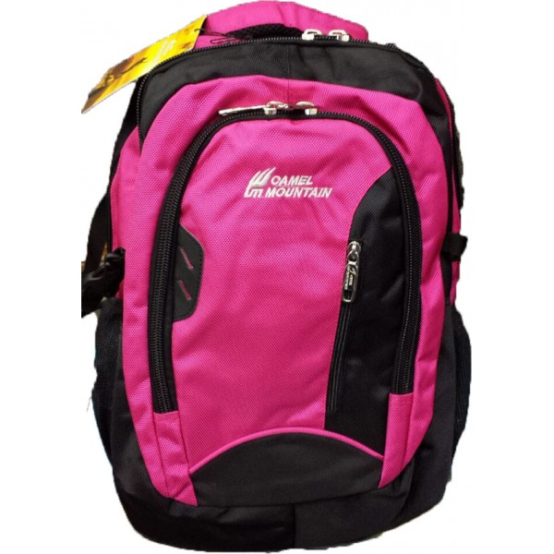

# CAMEL MOUNTAIN &PINK -006

|  |  |
| --- | --- |
| BRAND | CAMEL MOUNTAIN |
| ITEM DIMENSION | 2 x 4 x 12.13inches |
| MODEL NAME | 006 |
| COLOR | BLACK & PINK |
| PRICE | **RS 1500** |